# Project Design Phase-I Solution Architecture

|  |  |
| --- | --- |
| Date | 21 October 2022 |
| Team ID | PNT2022TMID20496 |
| Project Name | Project - Smart Farmer-IOT Enabled Smart  Farming |
| Maximum Marks | 4 Marks |

**Problem Statement:**

Farmers should be in the farm field to monitor their crop field, if any emergency occurs for farmer to go outside there will be lack of irrigation in farm field which lead to damage in crops health

# Solution:

IoT-based agriculture system helps the farmer to monitoring different parameters of his field like soil moisture, temperature, and humidity using some sensors by using a web or mobile application when the farmer is not near his field, he can make the decision whether to water the crop or postpone it by monitoring the sensor parameters and controlling the motor pumps from the mobile application itself.

# Solution Architecture Diagram:

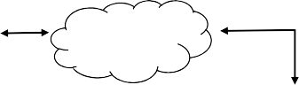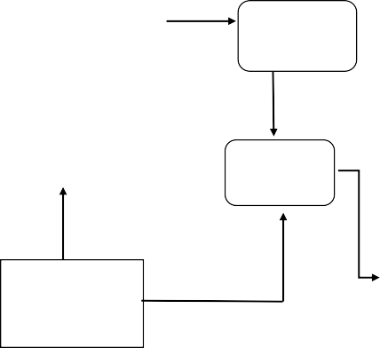

UV Sensor

**Humidity Sensor**

**Rain Fall Sensor**

**Cloud**

**DS18B20 Temperature Sensor Probe**

**User**

**Raspberry Pi**

**Relay**

**Dielectric Soil Moisture Sensors**

**Electrochemical Sensors**

**Water Pump**

**Power Supply**

**Irrigation System**